GREEN NANOSTRUCTURED BIODEGRADABLE MATERIALS
.
INTRODUCTION
Conventional disposable packaging items such as containers, trays, plates, bowls, and others, are commonly made from polystyrene or other synthetic hydrophobic plastics and also from paper or paperboard coated commonly with polyethylene. These materials are durable, moisture-resistant and grease-resistant.
The disposable items are produced by the industry in great quantities and are relatively inexpensive. After usage, these biostable goods are discarded in the environment and therefore create serious ecological problems [1-4]. Packaging waste forms a significant part of municipal solid waste and has caused increasing environmental concerns, resulting in a strengthening of various regulations aimed at reducing the amounts generated. Plastic waste imposes negative externalities such as greenhouse gas emissions or ecological damage. It is usually non-biodegradable and therefore can remain as waste in the environment for a very long time; it may pose risks to human health and the environment; in some cases, it can be difficult to reuse and/or recycle. The expected lifetime of polystyrene materials, for example, is several hundred years. Recycling of plastic items is an expensive process. Moreover, in some countries the recycled plastics are prohibited as a material for production packaging for food.
Among other materials, a wide range of oil-based polymers is currently used in packaging applications. These are virtually all non-biodegradable, and some are difficult to recycle or reuse due to being complex composites having varying levels of contamination.
The annual world consumption of non-biodegradable plastic packaging is about 200 million tons. More 150 million tons are annual world consumption of paper and board packaging. The consumption of coated paper and board are about 45 million tons per year. The global paper packaging market was $213.8 billion in 2014 and is estimated to reach $306.73 billion by 2020 growing at a Compound Annual Growth Rate (CAGR) of 6.2%. Of the paper packaging market, paperboard is estimated to be the fastest growing market with a forecasted growth rate of 7.5% during the period 2014-2020 [5,6].
Figures 1 [7] and 2 [8] illustrate stable growth of production and consumption of plastic packaging materials in Europe

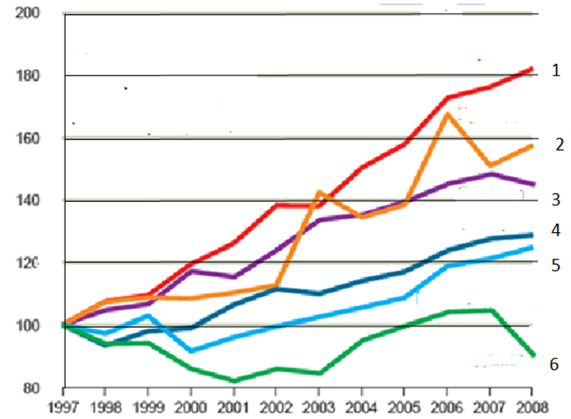

Figure 1. Tendency of production of plastic packages in Europe (Index = 100 in 1997 ) : 1- Germany, 2- Ireland, 3- Belgium, 4- Sweden, 5- Great Britain , 6-Denmark .

In 2008, total generation of post-consumer plastic waste in EU-27, Norway and Switzerland was 24.9 Mt. Packaging is by far the largest contributor to plastic waste at 63%.
Due to biostability of synthetic materials the tendency to use biodegradable disposable packaging materials has steadily increased in the last decade. Recently, significant progress has been made in the development of biodegradable plastics, largely from renewable natural resources, to produce biodegradable materials with similar functionality to that of oil-based polymers. The expansion in these bio-based materials has several potential benefits for greenhouse gas balances and other environmental impacts over whole life cycles and in the use of renewable, rather than finite resources. It is intended that use of biodegradable materials will contribute to sustainability and reduction in the environmental impact associated with disposal of oil-based polymers.
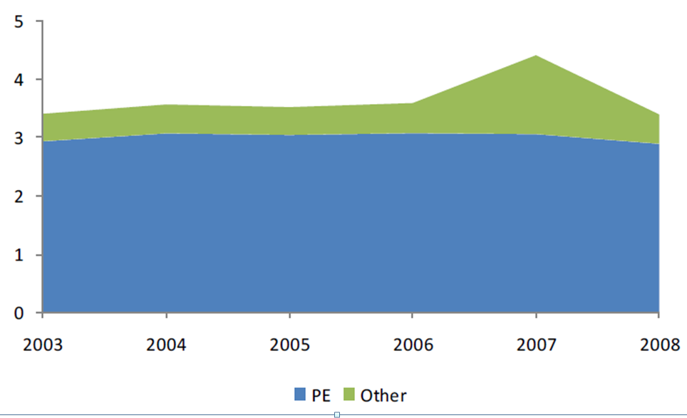
Figure 2. Volume of plastic and bags produced in EU, 2003-2208 (Mt)

The main approach has been the manufacture of inexpensive goods from biodegradable and compostable natural materials such as starch, cellulose, proteins etc. [9-14]. However, these natural biodegradable materials has several shortcomings, the most important being susceptibility to water, grease and various other liquids. The starch binder is water-soluble and penetrable to grease.
This chapter discusses the potential impacts of biodegradable packaging materials and their waste management, particularly via composting. It presents the key issues that inform judgements of the benefits these materials have in relation to conventional, petrochemical-based counterparts. Specific examples are given from new research on biodegradability in simulated ‘home’ composting systems. It is the view of the authors that biodegradable packaging materials are most suitable for single-use disposable applications where the post-consumer waste can be locally composted.
Cellulose materials - papers and cardboards, are widely used in the manufacturing of packaging. These materials are ecologically safe because they can undergo biodegradation and repulping. However, cellulose packaging is hydrophilic and porous and therefore swell in water . When exposed to water or significant amounts of water vapor, these packaging materials lose form-stability and become susceptible to breakage. Therefore, it fails to protect packaged products from the negative effects of water, greases, vapors, gases and other environmental factors. In order to give them barrier properties, cellulose substrates are laminated or coated with polyolefins (polyethylene, polypropylene) and other synthetic hydrophobic polymers. Despite the fact that cellulose-polyolefin composites possess good barrier properties, their prospective application is problematic for ecological reasons. Since they are non-biodegradable and non-repulpable as papers or cardboards, and non-recyclable as common plastics, cellulose-polyolefin composites waste accumulates on dumps in immense amounts and pollutes the environment. This creates a sharp ecological problem.
To overcome the shortcomings of the natural hydrophilic materials, it is necessary to develop advanced, environmentally friendly, hydrophobic polymer materials that are capable of recycling and biodegradation..
The most attempts to manufacture biodegradable packaging were focused on developing biodegradable plastic films. Creation of biodegradable packaging products based on improving low barrier properties of cellulose-based materials by coating with special polymer composition. Moreover, the coated cellulose material is recyclable and biodegradable, like as ordinary paper or cardboard. These products can be included also into pulp composition.
In this chapter, the technology of novel protective nanocoatings on surface of natural biodegradable packaging materials is described.
One from the most developed fields of the nano-technology is nanoplastics containing polymer binders and inorganic nanofillers, such as clay, silica, chalk, titanium dioxide, ceramics, etc. However, the inorganic nanofillers have the following disadvantages:
- High density increases weight of composites and articles;
- High abrasibility decreases life time of an equipment;
- High hardness hinders polishing of coatings;
- Low bonding ability with organic polymers hinders strength rising;
- Bio-stability hinders production biodegradable plastics ;
- Settling ability in liquid systems causes to phases separation.

In contrast with nanoinorganic, nanoorganic fillers can contain various functional groups allowing them bonded with an organic polymer that leads to strength rising of the plastics. Moreover, organic nano-fillers such as nanocellulose will have low' density, low hardness and abrasibility . as well as increased settling stability of dispersions, etc. Besides, nano-organic fillers made from cellulose are biodegradable. Therefore, our aim was development preparation method of nano-cellulose and study main application fields of the new nanoproducts.
This chapter discusses the potential impacts of biodegradable packaging materials and their waste management, particularly via composting. It presents the key issues that inform judgements of the benefits these materials have in relation to conventional, petrochemical-based counterparts. Specific examples are given from new research on biodegradability in simulated ‘home’ composting systems. It is the view of the authors that biodegradable packaging materials are most suitable for single-use disposable applications where the post-consumer waste can be locally composted.
♦
♦ ♦
Skin has difficult multi-layer structure comprising exterior layer – stratum corneum, middle layer – epidermis and inner layer – dermis [15]. To prophylactic skin care, the cosmetic remedies can be used that act mainly on the skin exterior layer. In the case of skin injury or disease, a specific biocide (drug) is used that should be penetrate inside the skin through pores having average size of 50 µm. In order to prevent by-effects, improve effectiveness and impart the slow-release effect, as well as to extend application areas, a chemical attachment of the biocide to appropriate carrier should be performed.
Restricted materials are suitable as carrier of biologically active substances (BAS) in biology, medicine and cosmetics. This carrier should meet the following requirements:
- It should be generally recognized as safe (GRAS);
- To contain fine particles having a gentle sensation ;
- To be insoluble in water, oils and various organic solvents;
- To be able to modification in order to forming specific reactive groups capable to bound BAS
- To be stable to attached BAS;
- Not inhibit the attached BAS ;
- Not interact with other ingredients of the drug composition.

Microcrystalline cellulose (MCC) belongs to the GRAS-substances [16]. However, coarse particles (50-200 µm) and inertness hinder grafting of BAS to MCC and transdermal delivery of the particles through skin pores. To use cellulose particles as biocarrier, it is needed to reduce the size of the particles to nanoscale and turn the material in a reactive.
Method for preparation of the reactive nano-cellulose biocarrier and discussion about some its biomedical and cosmetic applications are presented .

NANO-CELLULOSE AND ITS APPLICATIONS

Materials and methods

As it known cellulose is the main building material of flora which forms the cellular walls of trees and other higher plants .The structure of a molecule of cellulose (Figure 3 ) is a high-chain polysacharide consisting of n-glycosidic residues, linked by ether bridges (1,4-β - glycosidic linkages)

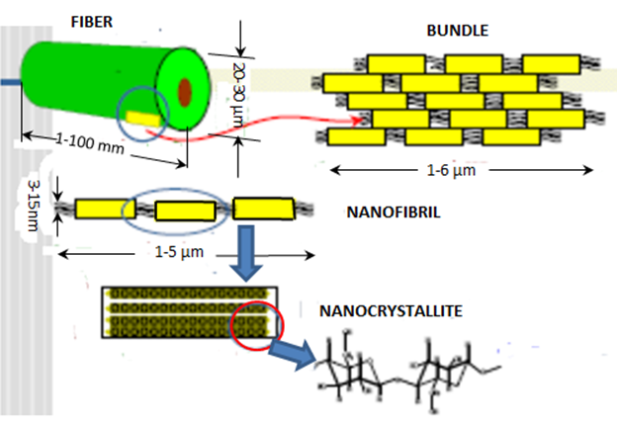

Figure 3. Structure of cellulose

Bleached wood cellulose (95% Alfa Cellulose, DP = 1180) was used as a raw material for preparation of the nano-cellulose (NanoCell).
NanoCell- products were manufactured by process showing in Table 1[17].

Table 1. Main stages for manufacturing of the nanocellulose

Stages | Process | Product
1 | Chemical depolymerization of the cellulose, washing  and filtration | Wet Cake
2 | Treatment of the microcrystalline cellulose water dispersion in a high pressure homogenizer | NanoCell -dispersions
3 | Centrifugal concentrating and ultrasonic disintegration | NanoCell-paste
4 | Freeze drying and vortex super-fine milling | NanoCell-powder

The initial cellulose raw material is cut on pieces and they are put in a glass reactor. A water solution containing the acidic catalyst, modifier is poured into reactor. The reactor is hermetically closed with a cover and the reaction system is kept at increased temperature for short time and then cooled. The cellulose slum' is filtered and wet cake is diluted up to 1-5% transferred in Gaulin-tvpc hoinogenizator and an inhibitor and a dispersing agent is added to the slurry. The dispersion is mechanically homogenized at 500-1000 bar and NanoCell dispersion is collected. This dispersion can be concentrated by centrifugation up to 25-30% solid paste of NanoCell. To producing dry NanoCell- powder. NanoCell-paste can be freeze-dried and disintegrated by vortex super-fine mill
Process of NanoCell production is illustrated in Figure 4.
Testing of NanoCell-materials and compositions was carried out by means of the following methods:
- XRD (Rigaku-Ultima Plus Diffractometer);
- SEM (Hitachi S-430);
- Viscometry (Ostwald's capillary viscometer);
- Laser-Light Scattering (Malvern's Mastersizer-2000 tester);
- Mechanical tests (LLOYD LR 50K instrument).

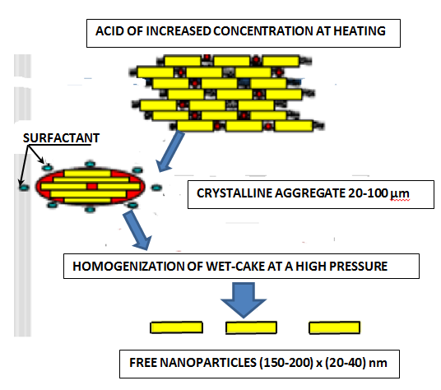

Figure 4. Process of NanoCell production

Using of the viscometry method for NanoCell investigations

This method is based on theoretical conceptions and experimental data about supermolecular structure of cellulose and its change during chemical treatments [E3-E5]. It is known that cellulose micro-fibrils contain amorphous regions and crystallites linked with intramolecular valence bonds. The amorphous regions are weak places of micro-fibrils accessible to chemical reagents, while crystallites are strong and inaccessible structural elements. Therefore, chemical treatment of cellulose with destructive reagents leads to breaking of chains in weak amorphous regions only and to decreasing in degree polymerization (DP) of cellulose (chemical cutting). After finishing of the depolymerization process in amorphous regions, the about constant DP-value "Level-off DP" (LODP) is reached. This value conforms to average DP of cellulose crystallites. The viscometry method is usually used for testing DP and LODP. If LODP was determined experimentally, the average length (L) of elementary⁷ cellulose crystallites can be calculated:

L = l · LODP

where l = 0.517 nm is length of glucopvranose link of cellulose,

Testing results

The dependence of DP on time of chemical cutting of cellulose chains in amorphous regions was investigated. As can be seen from Figure 5 [17], DP of the studied wood cellulose decreases until reaches about constant value corresponding to LODP. The determined LODP value of the studied NanoCell was 141. Then average length of elementary crystallites of NanoCell is: L = 0.517nm · 141 ≈ 73 nm.

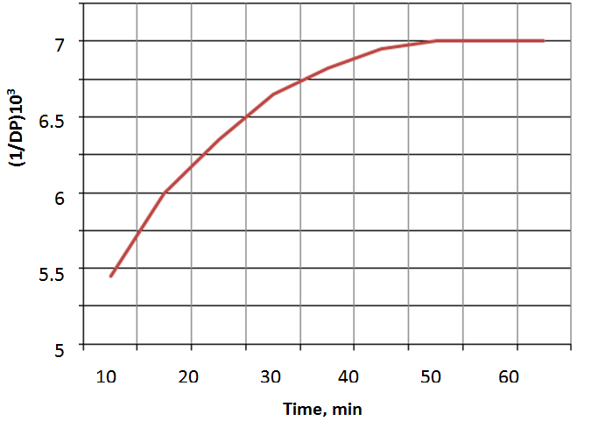
Figure 5. Degree of polymerization of wood cellulose as function of chemical cutting time

Investigation of the NanoCell by XRD method

The dry NanoCell powder was selected for X-ray analysis. The tablets were pressed from dry powder in order to obtaining X-ray diffractograms. The following characteristics of the sample can be calculated from XRD investigations [19,21]:
- Degree of Crystallinity:
DC = (S_{c} / S₀) · 100%,

where S_{c} - total surface of crystalline peaks; S₀ - total surface of diffraclogram.
- Average size of an elementary crystal (length – L₀ and width – H₀) was calculated in accordance with the equation:
L₀ (or H₀) = |(B₀ cosθ) / λ)² - (δ / d)²]⁻¹

where B₀ - corrected width of the peak; θ- diffraction angle; d - inecrplanar distance; δ - lattice distortion of the second type; λ - length of CuK_{a} X-ray wave (0.15418 nm).

Testing results

XRD of the NanoCell sample (Figure 6 [17]) was carried out using "Rigaku-Ultmia Plus" diffractometer.
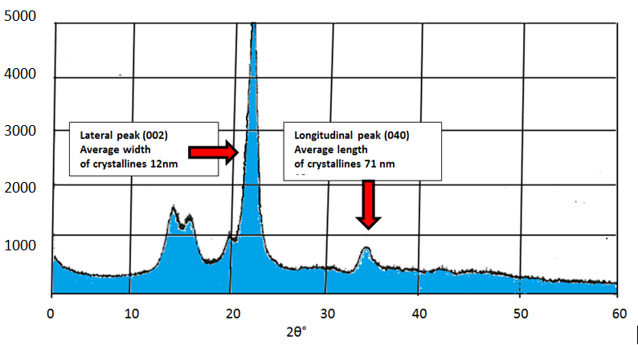
Figure 6. XRD of NanoCell with Cl-crystalline modification

- Degree of crystallinity : DC = 81%.
Lateral peak (002) has the following parameters: θ = 11.25°; d = 0.395 nm; B₀ = 0.02045 radian; δ = 0.040.
Calculated width of the elementary crystallites of NanoCeil :
H₀ = [(0.02045 · 0.9898 / 0.15418)² ̶ (0.04 / 0.395)² ]⁻¹ = 12 nm.
- Longitudinal peak (040) has the following parameters:
θ = 17.35°; d = 0.2585 nm; B₀ = 0.02 radian; δ = 0.0318.
Calculated length of the elementary crystallites of NanoCeil :
L₀ = [(0.02 · 0.9545 / 0.15418)² ‒ (0.0318 / 0.2585)²]⁻¹ = 71 nm.

As it is follows from XRD-results, the NanoCeil has Cl-crystalline modification. The elementary nano- crystallites arc anisometric having length 71 nm and width 12 nm.
So, both the viscometry and XRD methods evidence about nano-scale structure of elementary crystallites of NanoCell -samples.
NanoCell powder usually contains aggregates of the elementary crystallites. In order to find size of crystalline aggregates methods of Laser Light Scattering and SEM were used.

Method of Laser-Light Scattering (LLS)

This method underlies of Malvern's Mastersizer- 2000 Apparatus for measuring particle size distribution (PSD) and average particle size (D_{0.5}) of various dispersions and powders. As it is follows from testing results (Figure 7 [17]). NanoCell-dispersion contains small nano-crystalline aggregates with average size D_{0.5} about 200 nm.

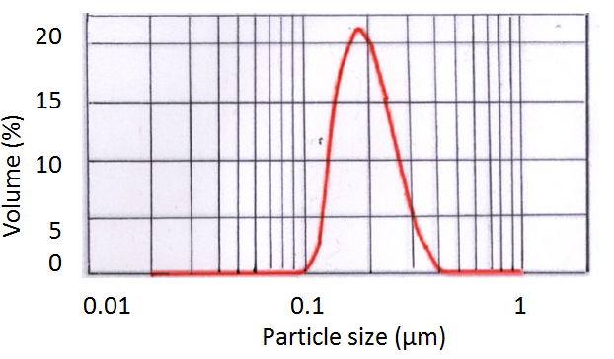

Figure 7. PSD-curve of the NanoCell-dispersion

Using of the SEM-method for NanoCell investigations

Dry powder of the NanoCell was prepared for SEM-investigation by chemical cutting of the initial cellulose, blending, homogenization, freeze-drying and mechanical disintegration. In order to improve contrast the NanoCell powder was preliminary coated by gold. As seen from Figure 8 [17] this sample contains ellipsoidal shape nanoparticles with average diameter 100-300 nm. This is correlated with LLS results.

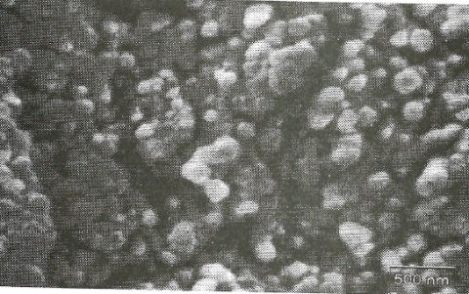

Figure 8. Scanning Electron Micrograph of the NanoCell sample

Potential application, preparation and investigation of composite materials based on NanoCell

Nanocellulose can be widely used in various fields of consumer industry, pharmaceuticals and construction owing to its unique physical and chemical properties, including correspondence to requirements of environmental safety. Some potential fields of application of NanoCell is shown in Figure 9.

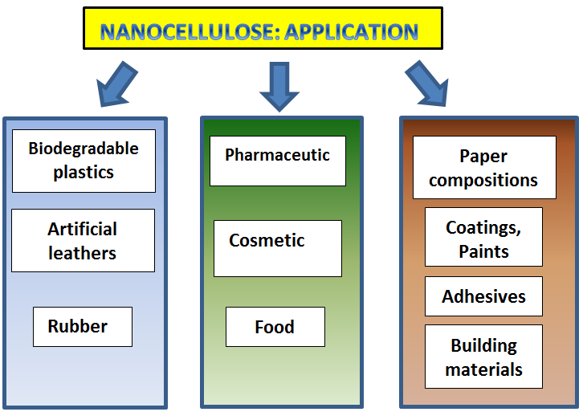

Figure 9. Some potential fields of application of NanoCell

The following NanoCell-containing materials were prepared:
- PVC-plastic filled with NanoCell-powder;
- Biodegradable PCL-polymer filled with NanoCell-powder;
- Paper pulp water-based composition filled with NanoCell-paste;
- Glue composition containing Polyvinylacetate latex, DOP and NanoCell- paste;
- Water-based paint composition containing UCAR-Latex, TiO₂ ,GCC. NanoCell-pasle and assistant agents (disperser, surfactant, thickener, etc.)

As it can see from mechanical testing (Figures 10,11 [17]). introducing of the NanoCell leads to considerable increasing in strength of PVC. PCL and paper materials. Moreover, filling of PCL with NanoCell contributes to increasing of biodegradation ability of the composite polymer material (Figure 12[17]).
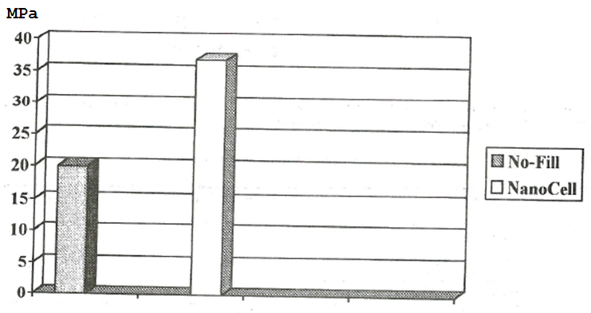
Figure 10. Tensile Strength (MPa) of initial PVC and PVC filled with 15% of NanoCell powder

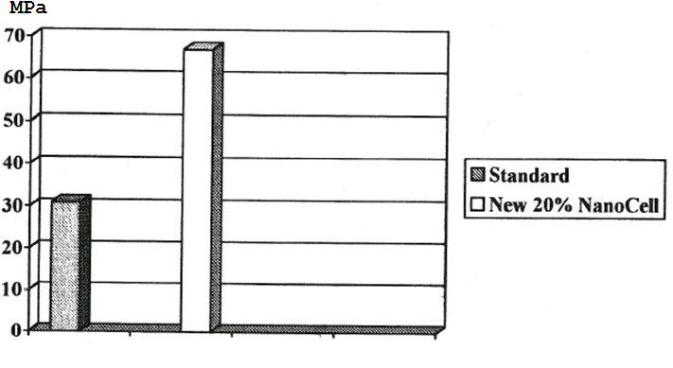
Figure 11. Tensile Strength (MPa) of initial paper and paper containing 20% of NanoCell

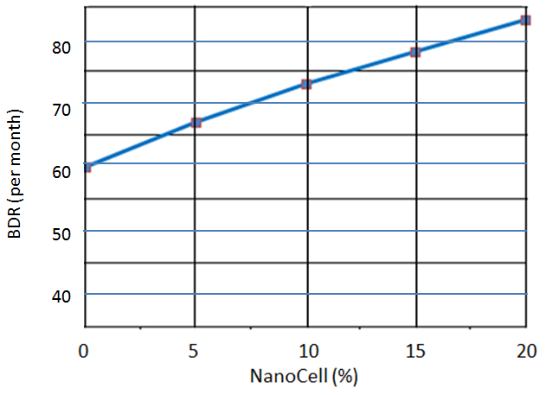

Figure 12. Bio-decomposition rate (BDR) of PCL plastics filled with NanoCell

Introducing of NanoCell in the glue composition permits improving tackiness and gluing strength (Table 2 [17]).

Table 2. Properties of Wood's Glues

Properties | Standard Glue | NanoCell-based Glue
Tackiness, Pa | 70 | 120
Strength , MPa | 6.4 | 6.7

Besides, water-based paint compositions containing TiO₂ –pigment, GCC-filler, NanoCell as an extender, UCAR binder and medium were prepared. Paint coatings were applied on to opacity charts of Sheen Instruments using the 100 microns bar applicator. Opacity value (contrast ratio) of the dn paint coating was measured by Sheen Opac Reflectomcter. NanoCell showed excellent extender properties for the paint containing mineral pigments. Introduction a low amount of the NanoCell into the paint composition permits replacing a significant amount of TiO₂-pigmcnt without changing in paint opacity value (Table 3 [17]).

Table 3. Characteristics of interior paint compositions based on UCAR-binder (Pigment volume concentration = 60%)

Components | Composition, %
 | No 1 | No 2
TiO | 20 | 13
GCC | 30 | 30
UCAR-binder | 25 | 28
Medium | 25 | 29
Characteristic
TiO -Saving. % | 0 | 35
Opacity value | 0.94 | 0.95

PROCESSING OF BIODEGRADABLE PACKAGING MATERIALS

Biodegradable packaging material GreetCoatTM

Hydrophobic synthetic polymers are widely used for production of packaging and others goods. These polymers have excellent protection properties, but they are highly resistant to biodegradation that caused polluting of the environment.
To solve the burning ecological problem of biostable polymeric wastes, various companies have been working out innovative polymers and polymeric materials that can be biodegradable: Biopol, Mater-Bi, Bioflex, PLA and others. But these polymeric materials have common disadvantages, like complicated technology, limiting in raw materials, high cost and dissatisfaction in some properties. World consumption of these biodegradable polymeric materials is only 0.1% from consumption of polyolefins and other biostable hydrophobic synthetic polymers. Therefore it is need in principal new conception for creating of hydrophobic biodegradable materials.
The goal was to provide a composition for forming a protective coating layer on a biodegradable natural material that imparts to the material improved waterproofing and grease-resistant properties. Fundamental idea was based on solution of the problem of susceptibility of natural materials to water and other liquids penetration, by filling the pores on the surface of the natural biodegradable packaging material with fine barrier particles.
Because paper and other natural materials contain micron- scale pores, filling of these micro-pores with protective biodegradable nanoscale particles closes the pores and thus makes the natural materials stable against penetration of water and other liquids. Nano-particles of cellulose in combination with some other additives appeared to be most suitable for the purpose in hand
Substrates for coating were paperboard of Weyerhaeuser Co and starch-based trays of Hartmann Co. Bleached Kraft pulp (92% α-cellulose, DP=1100) of Weyerhaeuser Co was used as an initial material for preparation of cellulose nanoparticles. Biodegradable Polycaprolactone (PCL) was delivered from Dow Plastics Co, while the natural hydrophobic agent - Carnauba wax from Strohmeyer & Arpe Co. Other suitable chemical – sulfuric acid, calcium oxide, organic solvent and some others were available from Sigma-Aldrich Co.
The initial cellulose sample was cut on pieces and mixed with water in a lab glass. Then 80 wt. % sulfuric acid (SA) was slowly added at cooling to obtain the required final concentration of SA of 60 wt. % and acid/cellulose ratio 5. The glass was placed into water bath having temperature 50℃ and heated at stirring for 1 h. Hydrolyzed cellulose was separated from the acid by centrifugation at the acceleration of 4000 g for 15 min, washed and separated once again. Then calcium oxide was added to the acidic slurry to neutralize the acid and precipitate the inorganic nanofiller – calcium sulfate.
The slurry containing agglomerates of nanoparticles was added to acetone solution containing 30-35 wt. % PCL and 1.5-2 wt. % of Carnauba wax. Then this mixture was homogenized by means of Gaulin-type homogenizer with 10 circulations at 100 MPa to obtain the protective nanocomposition for coating for natural biodegradable substrates.
The substrates were coated with the liquid nanocomposition by means of rod-type lab coater and dried at 100º C for 30 min. The weight of the dry coating on the surface of paperboard was 20 g/m² and on surface of the starch-based substrate was 40 g/m².
Particle size of the nanocoating was studied by a means of a Mastersizer-3000 apparatus of Malvern Instrument Ltd. Viscosity of the liquid compositions was measured by the Brookfield viscometer DVII at a rotation rate of 20 rpm. Water absorption of the coated substrates was determined by the Cobb test in accordance with ASTM D3285. The mechanical properties were tested by Instron 4201 - Test System. Biodegradability was evaluated by weight loss of materials at composting in wet soil under conditions described in ASTM D2020-B and ASTM D5988.
Results and discussion

After acid hydrolysis of the initial pulp and neutralization with calcium oxide about 15% wet-cake was obtained containing 60-65% nanocellulose and 35-40% inorganic nanofiller (CaSO₄). About 100 g of the wet-cake were mixed with 200 g solution containing biodegradable polymer and natural hydrophobic agent and then homogenized. As a result the coating composition was obtained (Table 4 [22).
Investigation showed that this composition has viscosity about 300 cP and average size of the solid particles about 170 nm (Figure 13 [22]).

Table `4. Main ingredients of the coating composition

Ingredient | Content,  wt. %
Solid nanocellulose | 3.0-3.3
Solid inorganic nanofiller | 1.8-2.0
Soluble polymer | 20-23
Soluble wax | 1.0-1.3
Organic solvent | 42-45
Water | 27-28

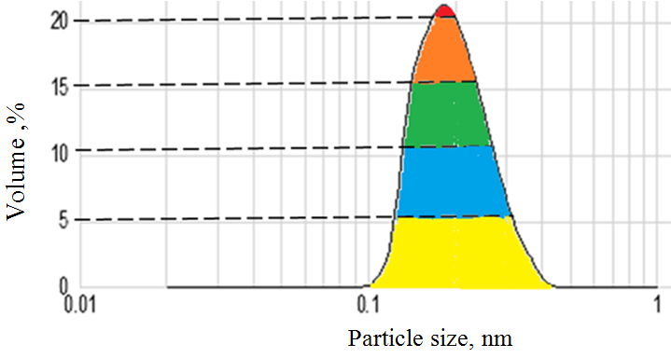

Figure 13. Size distribution of the solid nanoparticles in the coating composition

After coating of the substrates, increase of mechanical properties was observed (Figure 14[22]). Initial substrate in wet state loses about 90% of its strength, while the coated substrate after wetting, vice versa, maintains up to 90 % its strength. Besides, introduction of the nanoparticles into coating composition promotes obtaining higher mechanical properties of the coated substrate.

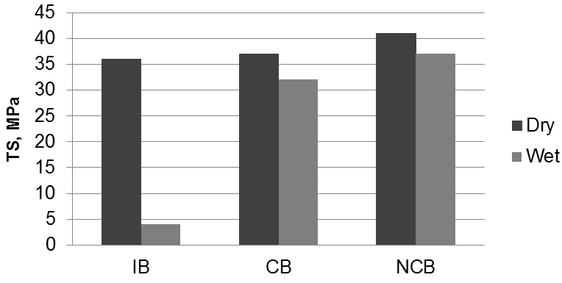
Figure 14.Tensile strength (TS) in the dry and wet state of the initial paperboard (IPB), board coated with composition without nanoparticles (CB) and board coated with composition containing nanoparticles (NCB)

The initial substrates don’t possess barrier properties to water and grease. In contrast, coating of the substrates with nanocomposition imparts to hydrophilic materials the increased barrier properties (Table 5 [22).

Table 5 Barrier properties of the initial (IB, IS) and nanocoated (NCB, NCS) materials

Substrate | Grease  Kit No | Water Cobb₃₀,  g/m²
IB | 1-2 | 170-200
NCB | 10-11 | 10-15
IS | 0 | 480-540
NCS | 8-9 | 20-25

Note: IB and IS are initial board and starch-based tray; NCB and NCS are nano-coated board and starch-based tray

Due to special composition of the coating, the coated substrates decompose in the wet soil during a relative short time (Figure 15 [22]).

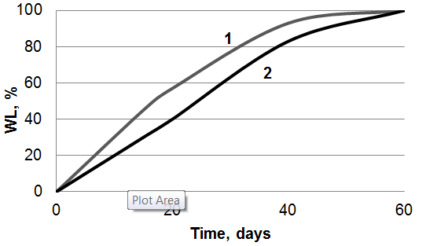
Figure 15. Weight loss (WL) of the initial (1) and nanocoated (2) paperboard due to biodestruction in wet soil

Comparative properties of the GreenCoatTM composition with the similar biodegradable package materials are shown in Tables 6,7

Table 6. GreenCoatTM comparative table

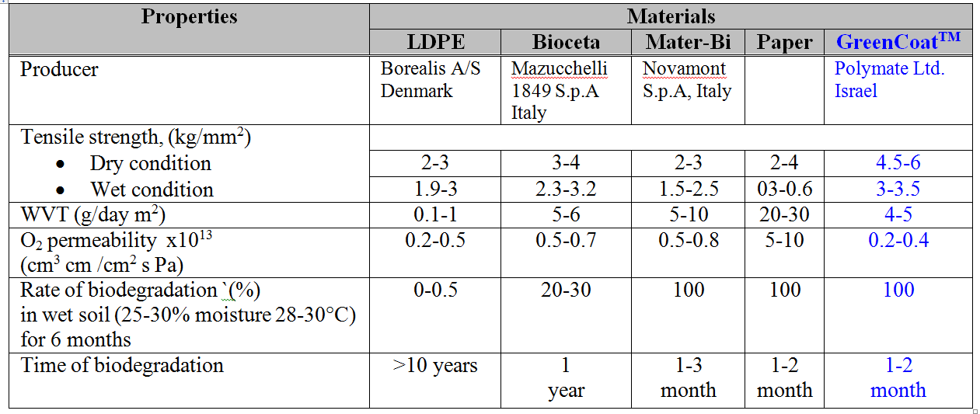

Table 7. Properties of cardboard coated by synthetic rubber and GreenCoatTM

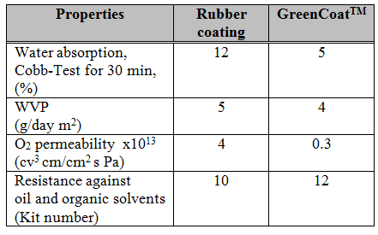

Patent [9] present the results of experimental investigation of the some biodegradable nanocellulose composites samples ( Table 8).

Table 8. Results of water penetration (Cobb test for 30 min.), grease resistance (3 Kit test number or degree), and biodegradability time (BDT- full weight loss during composting in wet soil.

Sample | Particle size (nm) in coating composition | Coating weight (g/m³) | Cobb Test  (g H₂O/ m²) | Grease-resistance (degree) | BDT  (month)
1 | 240 | 20 | 18 | 12 | 2
2 | 180 | 15 | 21 | 12 | 3
3 | 200 | 40 | 27 | 10 | 2
4* | 6000 | 20 | 62 | 8 | 2
5* | 10000 | 40 | 75 | 5 | 2
* Comparative samples
As shown in Table 8, nanocompositions protect the natural packaging materials against water and grease, while micro-compositions containing coarse micron- scale particles have poor barrier properties. Moreover, natural packaging materials coated with the proposed nano-compositions are biodegradable and decompose fully for two to three months when composting in wet soil

Biodegradable packaging materials BHM

Kraft-paper with a density of 50-70 g/m² and cardboard with a density of 300-400 g/m² were selected as cellulose substrates. Films of biodegradable plastics [23] :
- Mater-Bi (Novamont Co.)
- Natura (Natura Co.),
- Biopol (Monsanto Co.)

were used for protective coating of the cellulose substrates. The biodegradable plastics Mater-Bi and Natura contain polycaprolactone (PCL) and starch; Biopol contains poly-hydroxy-butyrate-valerate (PHBV) .
The novel various biodegradable hydrophobic polymer materials (BHM) in the form of aqueous dispersions were applied [24]. :
- BHM-B - the basic type of BHM) was synthesized by emulsion polymerization of vinylacetate with the addition of a small amount of acrylic acid and other needed reagents. The concentration of vinylacetate and acrylic acid copolymer (VAC) in BHM-B emulsion is 35-45%. BHM-B is intended to create a grease-repellent coating on the surface of cellulose substrate. Other types of BHM composition were also developed.
- BHM-GW intended to create a grease- and water-repellent coating, was prepared by the addition of a crosslinking agent (for example, dimethylolurea) to the basic BHM emulsion.
- BHM-W is intended for waterproof coating; it was prepared by the addition to the basic BHM emulsion of a crosslinking agent and an emulsion of the natural Carnauba wax.
- BHM-U - two-layer-deep barrier coating of the type was applied on the substrate surface: the first, primer, layer consists of BHM-B and the second layer consists of a hot-melt glazing composition of natural wax, higher aliphatic acids and natural fillers.

Polymer films were applied on the substrate surface by means of lamination technology. Coating of the cellulose substrate with BHM emulsions and compositions was carried out by bar coater. Emulsion-coated substrate was dried at a temperature of 150-180 °C.
The layer composites created have "bread- butter" (A) or "sandwich" (B) structures (Figure 16[25]). These composites can consist of a thin (10-30 micrometer) protective coating layer (1) and a relatively thick (0.5-2 mm) layer of cellulose substrate (2).

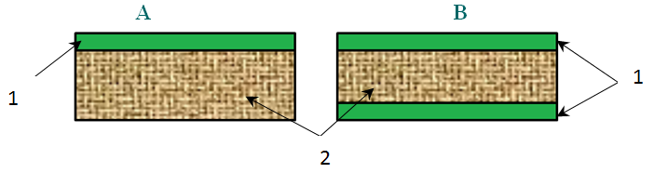

Figure 16. Structure types of the layer composites: 1- polymer coating; 2- cellulose substrate
Production scheme of the coating process is illustrated in Figure 17

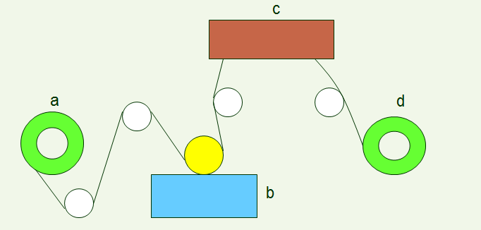

Figure 17. Scheme of coater: a-Unwind station; b- Coating station; c- Drier; d- Rewind station

The effective size (diameter) of micropores in a protective coating layer was measured by the method of water vapor sorption. The effective diameter of micropores was calculated in accordance with the equation [25]:

d = 4V_{p} / S

where S is the specific surface of a polymer material and V_{p} is the specific volume of micropores measured at a relative humidity close to 1.
For example, the BET isotherm of water vapor sorption for Coating A is shown in the Figure 18[25]. The calculated specific surface (S) of the polymer coating is 35 m²/g and specific volume of micropores (V_{p}) is 0.37 cm³/g; Therefore, the effective diameter of micropores (d) in Coating A is about 42 nm.
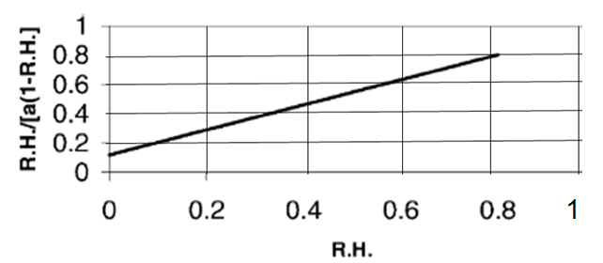
Figure 18. The BET isotherm of Coating A

The following barrier properties of composite materials were studied:
- Water vapor transmission rate (WVT) through a sample tested at normal conditions (25°C, R.H. = 0.85) [26].
- Absorption of liquid water for 30 min (A) measured by the Cobb Test method [27].
- Permeation of O₂ (P[O₂]) [28].
- Grease penetration (Kit no.) tested by the 3M Kit method [C6].
- Time of biodegradation (t) and weight loss of the composites in composting conditions were measured by the methods [29,30].
- Repulping degree (R.D.) of the composite materials was checked by method [31] .

Results and discussion

The barrier properties of the layer composite materials having various protective coatings are shown in Table 9[25].
Table 9. Barrier Properties of the Various Layer Composites

Coating  (thickness 25 μm) | Kit no. | A  g/m² | WVT  g/day m² | PO₂
Mater-Bi | 12 | 13 | 330 | 16
Natura | 12 | 11 | 270 | 14
Biopol | 12 | 5 | 40 | 9
BHM-B | 12 | 9 | 110 | 10
BHM-W | 8 | 3 | 30 | 9
BHM-GW | 12 | 7 | 100 | 10
BHM-U | 12 | 1 | 4 | 7

As can be seen from the experimental results, the value of grease penetration is similar for all the composites studied. However, there is a considerable difference in other barrier properties of the various materials. The coatings of Mater-Bi and Natura do not insure that the composite materials constitute a barrier against water penetration, or moisture and oxygen permeation. The best barrier properties observed are for the composite having the BHM-U coating.
The effective diameter of the micropores (d) and time of degradation (t) in the various coatings of the composite materials is shown in Table 10[25] .

Table 10. Sizes of micropores and time of degradation in the coatings

Coating  (thickness 25 μm) | D  nm. | t  months
Mater-Bi | 60 | 2
Natura | 42 | 2
Biopol | 17 | 5
BHM-B | 30 | 3
BHM-W | 16 | 5
BHM-GW | 20 | 3
BHM-U | 5 | 6

The smallest micropores, with an effective size of about 5 nm, were found for the composite having the BHM-U coating; and the largest, about 60 nm, were found for the material having the Mater-Bi coating.
In order to prevent pollution of the environment waste materials should be broken down and destroyed. The waste of all advanced composite materials is biodegradable and can be decomposed in composting conditions. Decreasing the thickness of the protective coating leads to a reduction in the time taken for biodegradation. Another way of to get rid the waste is to repulp it and then use the recycled composites in the paper industry. This is preferable to biodegradation of the waste.
As can be seen from the results (Table 11[25]), the composites having coatings of the BHM type are repulpable, while the composites having coatings of Mater-Bi, Natura or Biopol are non-repulpable and that limits their application

Table 11. Repulping degree (R.D.) for various types of layer composite materials

Coating  (thickness 25 μm) | R.D.  % | Note
Uncoated substrate | 100 | Repulpable
Mater-Bi | 38
Natura | 36 | Non-repulpable
Biopol | 31
BHM-B | 93
BHM-W | 90 | Repulpable
BHM-GW | 86
BHM-U | 83

A correlation between the sizes of the coating micropores and the properties of the layer composite materials was found. Decreasing the micropore diameter of the protective coating reduced the water absorption and moisture and oxygen permeation, as well retarding the biodegradation process of the composite materials (Table 11, Figures 19-21 [25]).

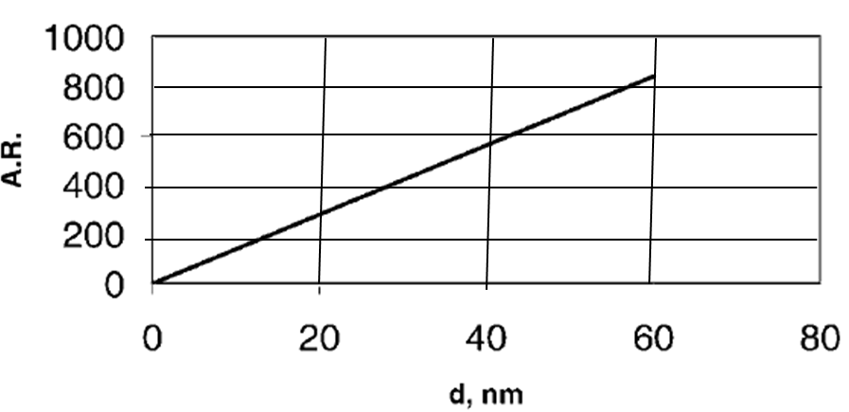

Figure 19. Correlation between micropore size (d) and rate of liquid water absorption (A.R.).
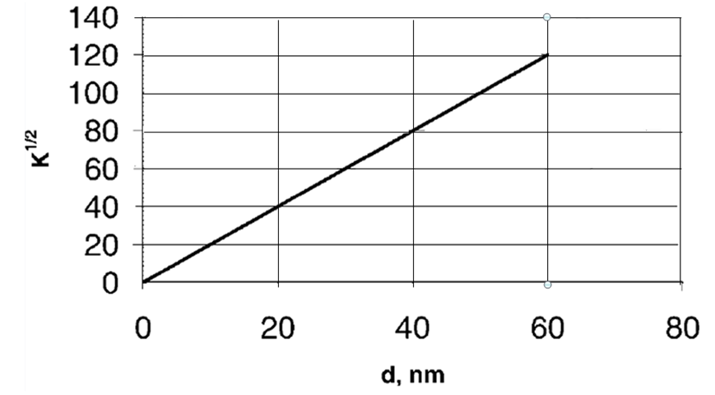

Figure 20. Correlation between micropores size (d) and coefficient of water vapor transmission (K).

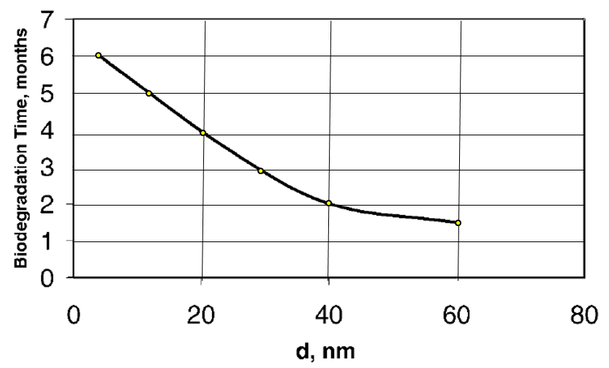
Figure 21. Dependence of biodegradation time of composite materials on size of micropores in protective coatings

The larger micropores and poor barrier properties of the composites having PCL-based polymer coatings (Mater-Bi and Natura) can be explained by the loose packing of the supermolecular structure in these polymer layers. The more dense supermolecular structure of PHBV-based Biopol coating and VAC-based BHM coating insures better barrier properties in the composite materials.
Sizes of micropores and the barrier properties of the dense two-layer BHM-U coating are similar to polyolefin coating. Therefore, the environment- friendly, recyclable composite material having this coating can be used as instead of the environment- polluting, non-recyclable polyolefin-based laminate.
The Table 12 contains for example characteristics of lBT version of BHM aqueous polymer emulsion.

Table 12. Characteristics of 1BT- version of BHM aqueous polymer emulsion.

Characteristics | Value
Solid content, (%) | 35-36
Density, (g/cm³) | 1.03-1.05
Viscosity, (cps) | 100-150
pH | 7-7.5

Properties of cardboard coated with lBT-version of BHM are following (Table 13).

Table 13. Characteristics of cardboard coated with lBT-version of BHM

Characteristics | Value
Coating weight, (g/m²) | 5-10
Tensile strength, (MPa) | 40-50
Cobb Value for 30 min, (g/m²) | 10-20
WVT (g/day m² at RT) | 50-60
3M Kit number | 6-7
Time of biodegradation, (months) | 2-4
Repulpability | Repulpable

It should be noted that within the framework of the patent [24] eighteen different cellulose waterproof biodegradable composites are described in detail. These composites consist essentially of cellulose and hydrophobic polymer-based component.

The composition of the polymer-based component comprises:
- 45-94 weight % of a first polymer, which is preferably polyvinyl acetate, said polymer is capable of cross- linking and contains about 2 to 8 wt % of free hydroxyl groups.
- 4-28 weight % of a second polymer, which is non cross-linked and capable to impart to the first polymer improved elastic properties.
- 2-20 weight % of a cross-linking agent, having at least two functional hydroxyl, carboxyl, amine and/or aldehyde groups.

Specific properties of the suggested cellulose composites are shown in the Table 14 [24] below.

Table 14. Properties of the cellulose composites

Cellulose composites, no. | 1 | 2 | 3 | 4 | 5 | 6 | 7 | 8 | 9
Water absorption, wt, % | 13 | 11 | 12 | 5 | 18 | 21 | 5 | 17 | 14
Water absorption, after folding wt, % | 13 | 12 | 12 | 7 | 19 | 23 | 6 | 30 | 15
Weight loss ,% for 3 month due  to biodegradation | 93 | 90 | 93 | 88 | 95 | 100 | 72 | 100 | 100

Table 14. (Continued)

Cellulose composites, no. | 10 | 11 | 12 | 13 | 14 | 15 | 16 | 17 | 18
Water absorption, wt, % | 4 | 3 | 26 | 10 | 5 | 7 | 6 | 3 | 2
Water absorption, after folding wt, % | 6 | 4 | 30 | N/A
Weight loss ,% for 3 month due  to biodegradation | 70 | 55 | 95 | 93 | 90 | 88 | 92 | 84 | 80

As is shown in [24] the equivalent ratio of functional groups in cross-linking agent to the stoichiometric content of free OH-groups in the PVA, should be 0.4 to 1.2. It has been empirically revealed that if the above ratio is less than 0.4 the cross-linking process does not take place; and if the ratio is more than 1.2 the cross-linking degree is not increased and does not render the obtained composite material more waterproof. It is advantageous, if the weight ratio PL/PVA lies in the range 0.05 to 0.43, and PL-content in the polymer-based component lies in the range 4 to 28 wt %. Decreasing PL/PVA ratio below 0.05 or PL-content below 4 wt % renders the obtained composite material more rigid (cracks after folding) and less waterproof (see example 8). Increasing of PL/PVA ratio above 0.43 or PL-content above 28 wt % renders the obtained composite material less biodegradable (see example 7).

Basic principles for biodegration of polymers
The decomposition process of the waste of the novel composite materials and articles in wet soil occurs under the effect of various microorganisms, fungi and bacteria. These microorganisms exude hydrolases, esterases, peptidases, oxydases, reductases and other enzymes, which are biological catalysts of the degradation process.
Аn organic polymer is capable of biodegradation if it contain specific bonds sensitive to enzymatic destruction, as example, esteric (1), acetalic (2), peptide (3) bonds [32]:
(1) -R-0--OO
(2) -R-0C--0-
(3) -R-NH~C=0

Natural hydrophilic polymers such as cellulose starch, proteins and others and also syntheti hydrophilic and hydrophobic polymers, having the above-mentioned specific bonds, are biodegradable.

Biodegradation of elaborated hydrophobic polymer coating occurs in wet soil under normal enzymatic action of various microorganisms - fungi and bacteria, as follows:

- In aerobic conditions (top soil layers)
C_{n}H_{m}O_{k} (BHM) + O₂ + enzymes = CO₂ + H₂O + Biomass (Humus)
- In anaerobic conditions (lower soil levels)
C_{n}H_{m}O_{k} (BHM) + enzymes = CH₄ + Biomass (Humus

The decomposition of the biodegradable composite occurs in three basic steps [32]:
- The first step is the process of the enzymatic detachment of lateral groups, as example:

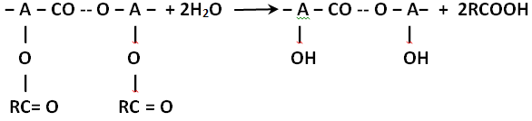
- The second step is the process of the enzymatic depolymerization as example:

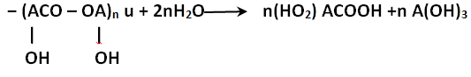

- The third step is the metabolic conversion of monomeric products into water, carbon dioxide (in aerobic conditions) or methane (in anaerobic conditions), as example.
Microorganisms of soil after finish of their vital function are converted into humus. Thus, only the environment friendly substances are formed as result of an organic polymer biodegradation in aerobic conditions: water, carbon dioxide and humus. There are also additional factors that are influenced on decomposition of biodegradable polymers. Increasing in degrees of polymerization and crystallinity delays biodegradation process of a polymer. Porous polymer decomposes fester than monolythic . and glass-type polymer decomposes slowly than elastic.
Decomposition of cellulose base coated with BHM at composting conditions is only slightly longer than the basic cellulose material (Figure 22). Moreover the coated cellulose substrate is repulpable and can be utilized together with uncoated cellulose materials
Soil microorganisms, after finishing their vital function, are converted into humus. Thus, in aerobic conditions only environment-friendly substances are formed as a result of the decomposition of biodegradable polymer material.
The coated substrates - novel layer composites - are produced on a basis of plant raw materials. The end products - water, carbon dioxide and humus - formed as result of biodegradation of the composite materials, are returned to their natural sources (Figure 23 [25]).
The layer composites made by lamination with films of Mater-Bi, Natura, Biopol, etc. are biodegradable, but non-repulpable. Only composite materials having BHM-type coatings are both biodegradable and repulpable. Widespread use of the novel composite materials will improve the ecological state of the environment.
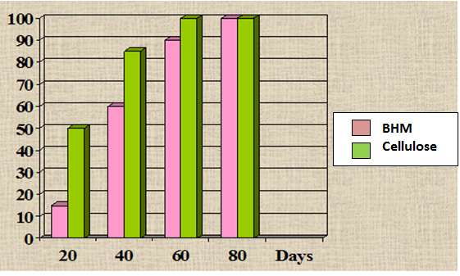
Figure 22. Weight loss, % of materials in wet soil

..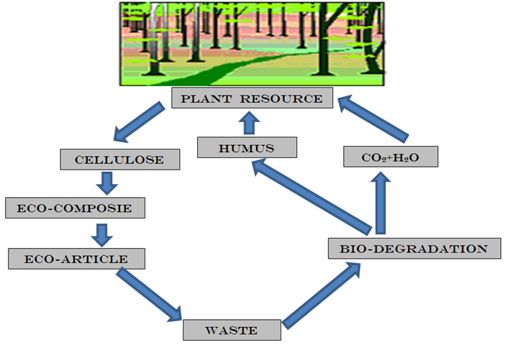

Figure 23. Biodegradable cycle of the novel composite material in nature

It should be noted that within the framework of the patent [24] eighteen different cellulose waterproof biodegradable composites are described in detail. These composites consist essentially of cellulose and hydrophobic polymer-based component.
The composition of the polymer-based component comprises:
- 45-94 weight % of a first polymer, which is preferably polyvinyl acetate, said polymer is capable of cross- linking and contains about 2 to 8 wt % of free hydroxyl groups.
- 4-28 weight % of a second polymer, which is non cross-linked and capable to impart to the first polymer improved elastic properties.
- 2-20 weight % of a cross-linking agent, having at least two functional hydroxyl, carboxyl, amine and/or aldehyde groups.

Application of the novel biodergadadle packaging materials

- Everyday Items: Trash bags, grocery bags, cups, plates, tablecloths and other household goods, etc.
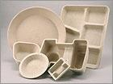

- Packaging Materials: Carton boxes, disposable containers for food processing ; Bags, boxes and containers for industrial products, building materials and chemicals, etc.

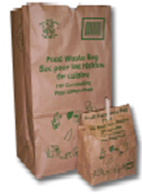

- Agricultural Use: Composting bags for agriculture wastes, bags for fertilizers, mulch sheets, flowerpots, seeding planter trays, etc.
- Textile and Polymer Industry: Hydrophobizing of natural textile materials; Production of synthetic leather, Biodegradable membranes ,etc.
- Sanitary Products: Protection layer for disposable hygienic materials like diapers, sanitary napkins, panties, towels etc.
- Other Applications: Water-and grease resistant paper/board; Filler binding; Paper sizing; Printing compositions, etc.

NANO-CELLULOSE AS PROMISING BIOCARRIER

Materials and methods

The pure cotton cellulose (DP=3000, 98.7% α-cellulose) was used as initial cellulose materials. The initial cellulose was treated with cellulase complex of Trichoderma reesei in a bioreactor. In order to prevent aggregation of the fine particles, all experiments were carried out using never dried or non-water dried samples. The bio-hydrolyzed cellulose was washed and squeezed on vacuum filter, and the wet cake was chemically modified to introduce form carbonyl and some other type of specific functional groups. Then, BAS, e.g. an enzyme, was coupled to the specific groups. The semi-product was diluted with water and dispersed by high-pressure homogenizer APV-2000 [33].
Average degree of polymerization (DP) of the cellulose samples was measured by Cuen-viscosity method. Diffract meter Rigaku-Ultima Plus (CuK– radiation, λ=0.15418 nm) was used for X-ray investigations. Degree of cellulose crystallinity and average lateral size of crystallites was calculated according to improved methods [34, 35]. The particle size distribution and the average particle size of aqueous suspensions were tested by a method of laser-light scattering using Malvern's Mastersizer-2000 apparatus. Scanning electron micrographs were obtained with a Hitachi S-430 apparatus.
Activity of free and coupled drugs was tested by standard biological methods.
Results and discussion

The process for preparation of the biocarrier includes the following main steps:

1. Controlled bio-depolymerization of initial cellulose up to minimal "level-off" DP; Washing and squeezing to obtaining "wet-cake".
2. Modification in order to introduce specific functional groups and joint various biologically active substances to fine cellulose particles.
3. High-power mechanical disintegration of the modified cellulose particles in liquid media to produce dispersions of the bioactive nano-cellulose.

This process can be represented by means of the following scheme:

Step 1: Enzymatic hydrolysis

The initial cellulose is treated with the cellulase complex allowing selective cleavage of the macromolecular chains in the poorly ordered non-crystalline domains. The catalytic splitting of the poorly ordered domains promotes mechanical disintegration and forming superfine particles uniform distributed in a liquid medium (Figure 24[36]):
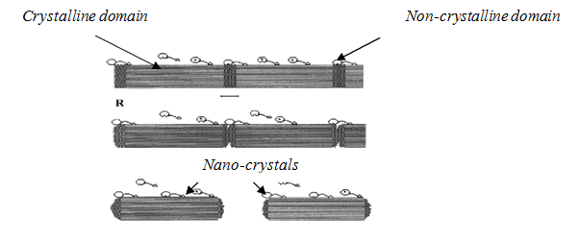
Figure 24. Scheme of enzymatic hydrolysis

Step 2 : Modification

To provide chemical coupling between the carrier and BAS, the specific functional groups (FG) should be introduced into particles, e.g. carboxyl, carbonyl, amine, epoxy, etc., (Figure 25 [36])

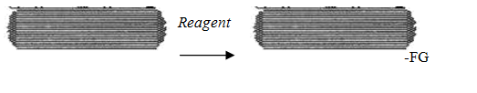
Figure 25. Scheme of modification

The non-dried particulate carrier having specific reactive groups that are able quickly interact with various bioactive substances (BAS) at optimal conditions allowing chemical attachment and forming of carrier-BAS complex (Figure 26 [36]):

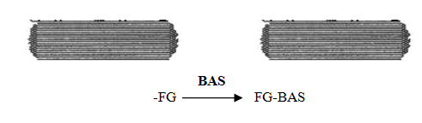
Figure 26. Scheme of attachment BAS to FG of the carrier

Step 3: High-power mechanical disintegration

Uniform length distribution of the nanocarrier particles in the water dispersion is shown in Figure 27 [36]

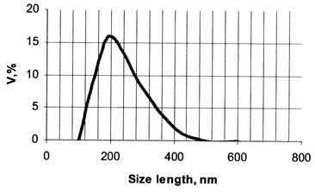

Figure 27. Distribution of the nanocarrier particles in the water dispersion

The structural characteristics of the nanocarrier having low amount of carbonyl groups (0.3-0.5%) are presented in Table 15 [36]

Table 15: Main characteristics of the nanocellulose carrier

Characteristics | Value
Crystalline modification | CI
Degree of crystallinity, % | 78-80
Degree of polymerization | 100-120
Average particle length, nm | 150-200
Lateral particle size , nm | 20-40
Length of crystallites, nm | 40-60
Lateral size of crystallites | 10-12

Electron microscopic investigations showed, the suspension of the nanocellulose carrier contains rod-like particles having length of 150-200 nm and lateral sizes of 20-40 nm (Figure 28 [36]).
Since individual nanocrystallites have diameter of 10-12 nm and length of 40-60 nm, each such nanoparticle is built from aggregates comprising about 2-4 of the crystallites.

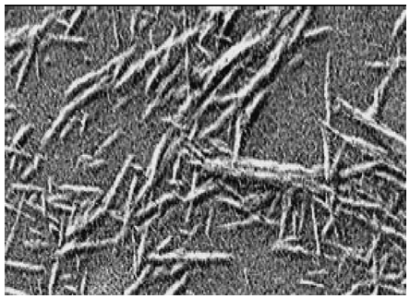

Figure 28.
SEM of rod-like particles of the nanocellulose carrier

Activity of the nanocarrier

To check activity of the coupled BAS the standard testing methods were used. For example, the activity of some enzymes was investigated by UV/VIS-spectroscopic method using specific substrates.
The free enzyme is are low stable in the aqueous solutions and it quickly deactivates, particularly
at increased temperatures. In contrast to the free enzyme, the enzyme coupled to nano-cellulose carrier is stable in the aqueous medium even at heating (Figure 29[36]

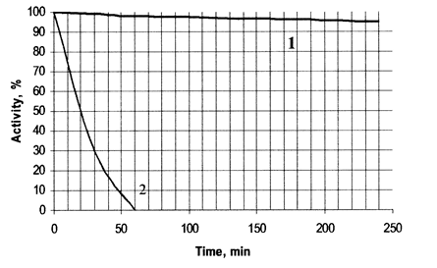

Figure 29. Activity of the coupled (1) and free (2) Trypsine in aqueous media at 60ºC

Applications

The application potential of the cellulose nano-carriers can be immense. Due to these unique properties and unlimited sources of the raw material, the biocarrier can find wide application in various health care branches, such as cosmetology, personal care, dermatology, otolaryngology, dietary food, biotechnology and some others.
The cellulose nanocarrier containing attached proteolytic enzymes can be used in cosmetology as gentle skin peeler, while containing bound aminoacids - as excellent nutrient agent for the skin. The carrier containing bound lipases can be used for selective degreasing of the skin. Nano-carrier with coupled proteolytic enzymes can be used in medicine for treatment of wounds, burns and also post-operating scars, while containing attached anesthetics - as an antipain agent

CONCLUSION

The organic nano-cellulose products have average particle size 100-300 nm in the form of water-based dispersion, paste and dry powder. Introducing of NanoCell to composite materials (plastics, paper compositions, adhesives, etc.) imparts them some peculiar properties, such as light-weight. increased strength. raised biodegradability, cost saving, etc. Moreover, NanoCell improves properties of water-based paints and coatings. Wide application of the organic NanoCel-products can create new nanomaterials having unique characteristics and properties
♦
♦ ♦
The main problem of natural biodegradable packaging materials is their susceptibility to water, grease and various other liquids. To solve this problem, the special protective nano-coating was developed and applied onto surface of these biodegradable substrates.
The green technology for preparation of the nanocoating containing nanoparticles of cellulose and inorganic filler, as well as the biodegradable hydrophobic polymer was proposed. This technology is zero-discharge because it provides a full utilization of the raw-materials. The initial cellulose pulp hydrolyzes completely and turns into the solid nanocellulose. Sulfuric acid turns into the solid inorganic nanofiller, while the residual acid returns and uses repeat for the hydrolysis step. The organic solvent after coating of the substrates is condensed to utilize again
As known, the paper, starch and other natural packaging materials contain micron-scale pores. Filling of these micro-pores with nanoscale particles in combination with polymer binder and some other additives closes the pores and thus makes the natural packaging materials more stable against effect of water, grease and other penetrable liquids. Therefore, the nanocoating containing the solid nanoparticles with average size about 200 nm imparts to natural packaging materials increased dry and wet strength, effective barrier against water and grease. Since the coating composition contains mainly biodegradable ingredients, the coated substrates can decompose in the nature during the relative short time.
The novel package materials consist of cellulose, biodegradable polymers and other biodegradable organic additives. Proposed nanostructured polymer coating (NPC) is hydrophobic, oil-, fat- and gasoline resistant, strong, inexpensive, recyclable and biodegradable. Due to biodegradable nature the package materials decompose in wet soil during two-three months by enzymatic action of various micro-organisms, such as fungi and bacteria, pretty much similar to ordinary paper forming a biomass. All the components of the materials have the FDA approval as food packaging materials.
The main advantages of various NPC versions are followings:
- High Strength .
Tensile strength is 40-60 MPa. Such strength characteristics, especially combined with low elongation and acquired water resistance of the material, make NPM unique and highly desirable for packaging applications
- Water Resistance .
NPC has a good water resistance to the cellulose basic material. Thus it has excellent prospects for many packaging applications. Most of the existing biodegradable packaging is not hydrophobic and fails in wetting conditions.
- Grease and Oil Resistance .
NPC is stable against greases, oils and non-polar organic solvents. Common paper and cardboard packaging is grease and oil penetrable.
- Recyclable.
NPC can be recycled and repulped like as basic material - cellulose, paper, board etc..
- Degradation in the Environment.
Natural microorganisms begin breaking down NPC and NPC Cellulose Substrate in water presence. Then microorganisms decompose the material with occurring metabolic reactions. The material is converted into carbon dioxide, water and biomass at composting in wet soil during 2-3 months. Thus this process completely coincides with the definition of biodegradability given by most experts.
- Relatively Low Cost .
The main obstacle to widespread use of biodegradable polymers is high cost. New biodegradable polymers: Mater-Bi, PLA, Biopol, etc. are significantly more expensive than common biostable polymers: PE, PP, PET, PVC. This expensiveness blocked the widespread adoption of biodegradable plastics in major consumer application. The high costs involved in the production of biodegradable polymers means that they cannot compete favorably with conventional polymers. NPC can be manufactured on the base of relative cheap components, with the existing industry equipment using existing technologies. Paper or board with NPC is only insignificantly more expensive to produce than to produce paper or board itself. Currently available degradable materials on the other hand can cost twice as much.
- Harmless.
NPC not contains harmful components. It is environment friendly and FDA -approved.
♦
♦ ♦

The cellulose nanocarrier has the following general features:
- Natural, biocompatible and harmless permitting use as a health care agent,
- Specific functional groups and developed surface promotes to expressed reactivity,
- Superfine and soft particles contribute to gentle sensation ,
- Excellent compatible with various organic ingredients ,
- Insoluble in water, oils and organic solvents ,
- Permits increasing the locale concentration of attached BAS ,
- Ensures slow-release effect of attached BAS,
- Increases stability of attached BAS to decomposition and deactivation
- Due to expressed thickening effect it imparts rheological properties ,
- Settling stability enables homogeneity of liquid-based systems .

The carrier-BAS complex has increased stability against external factors. Moreover, due to developed surface, this product can form high viscous suspensions and pastes that are convenient for applications. Various BAS-types such as enzymes, biocides, anesthetic, cosmetic and active health care agents can be attached simultaneously to the reactive nanocarrier.
Due to superfine nano-size, the particles of cellulose nanocarrier having coupled BAS are capable clean skin's micron-scale pores, open them and penetrate through the epidermis within the skin strata. This effect of the biocarrier can be employed at development of advanced types of biomedicals and cosmetics remedies used for gentle care and effective treatment of the skin.

REFERENCES

- Swift G. Non-medical Biodegradable Polymers: Environmentally Degradable Polymers. In: Handbook of Biodegradable Polymers, Harwood Academic, Amsterdam, 1997.
- Griffin G. J. L. Synthetic Polymers and the Living Environment. Pure and Applied Chemistry, 52, p. 399-407 (1980).
- Gautam R., Bassi A.S., Yanful E.K., A Review of Biodegradation of Synthetic Plastic and Foams. Appl Biochem Biotechnol. 141 (1), pp.85-108, 2007.
- Ioelovich M. Structure and Properties of Cellulose-based Biodegradable Hydrophobic Materials. J. Scientific Israel. Technological Advantages , 1(2), p.75-81 (1999)
- http://www.marketsandmarkets.com/PressReleases/paper-paperboard-packaging.asp
- http://www.businesswire.com/news/home/20151216005732/en/Research-Markets-Global-Paper-Packaging-Market-Worth
- http://www.envsec.org/publications/vitalwaste3_rus_1.pdf
- http://ec.europa.eu/environment/waste/studies/pdf/plastics.pdf
- Ioelovich M., Figovsky O., Leykin A. Biodegradable Nano-Composition for Application of Protective Coatings onto Natural Materials. US Pat. No 8268391 (2012).
- Perez J., Munoz-Dorado J., de la Rubia T., Martınez J. Biodegradation and Biological Treatments of Cellulose, Hemicellulose and Lignin: An Overview. Int. Microbiol. 5, p. 53–63 (2005).
- Degli-Innocenti F., Tosin M., Bastiol C. Evaluation of the Biodegradation of Starch and Cellulose under Controlled Composting Conditions. J. Env. Polym. Degrad. 6, p.197–202 (1998).
- Schwach E., Averous L. Starch-based Biodegradable Blends: Morphology and Interface Properties. Polym. Interface. 53, p. 2115–2124 (2004).
- Lu D.R., Xiao C.M., Xu S.J. Starch-based Completely Biodegradable Polymer Materials. Express Polymer Letters, 3(6), p. 366–375(2009).
- Zhang X.Y., Niu J.N., Tian Q.L. Study on the Biodegradability of Protein Fibers and Their Products in Activated Sludge. Adv. Mater. Res., 602-604, p. 1227-1230 (2012).
- http://www.drugdeliveryreport.com/articles/ddr_w2005_article10.pdf
- Ioelovich M., Leykin A., Bioresources. Vol. 3, (2008), p 170.
- Ioelovich M., Leykin A., Nano-Cellulose and its Applications, , Journal "Scientific Israel- Technological Advantages", Vol.6, No.3-4, 2004 pp.152-0157
- Ioelovich M.. Dizhbite T.. Plotnikov O. Effect of Parameters of Cellulose Supermolecular Structure on Stable Free Radicals upon γ-Radiation. - Cellulose Chemistry and Technology, 31. p. 291- 295 (1997).
- Ioelovich M. Concept of the Native Cellulose Structural Organization. - J. Scientific Israel. Technological Advantages. 1. No 1. p.68-77 (1999).
- Battista O.A. Mtcrocn stalline Cellulose. - In: Cellulose and Cellulose Derivatives. Parts 4-5. Ed. by N.M.Bikaies and L.Segal. Wiley Interscience. N.Y.. London. Sydney. Toronto. 1971.
- loelovich M.. Gordeev’ M. Crystallinity of Cellulose and its Accessibility during Deuteralion, Acta Polvmerica. 45. p. 121-123, (1994)
- Ioelovich M., Figovsky O., Green Nano-Protective Coating , Journal “Scientific Israel- Technological Advantages" Vol.15, № 2, 2013
- Witt U, Muller R, Klein J. Biologisch Abbaubare Polymere: Status und Perspektiven. FPZ: Braunschweig, 1997.
- Ioelovich M, Figovsky O. Hydrophobic biodegradable cellulose containing composite materials. US Patent no. 6294265.
- Ioelovich M., Figovsky O., Advanced Environment-friendly Polymer Materials, Polym. Adv. Technol. 13, 1112-1115 (2002)
- Standard Test Method for Water Vapor Transmission of Materials. ASTM E 96.
- Standard Test Method for Water Absorptiveness of Nonbibulous Paper and Board (Cobb Test). ASTM D 3285.
- Standard Test Method for Gas and Vapor Permeation through Polymers. ASTM D 1434.
- Quality Control of Treaded Paper and Board. 3M Kit Test.
- Standard Test Method for Mildew (Fungus) Resistance of Paper and Paperboard. ASTM D 2020 B.
- Determination of Weight Loss of Plastic Materials Exposed to Aerobic Compost. ASTM D 6003.
- Ioelovich M., Engineering of Environmental Friendly Polymer Materials , Journal "Scientific Israel- Technological Advantages", Vol.3, No.1-2, 2001 pp.152-157
- Ioelovich M., Leykin A., Cellulose Chem. Technol. Vol. 40, (2006), p. 313.
- Ioelovich M., Acta Polymerica. Vol. 43, (1992), p. 110.
- Ioelovich M., Journal "Scientific Israel- Technological Advantages",. Vol. 1 (1999), p. 68
- Ioelovich M., Figovsky O., Nano-Cellulose as Promising Biocarrier, Journal "Scientific Israel- Technological Advantages", Vol.10, No.1, 2008

